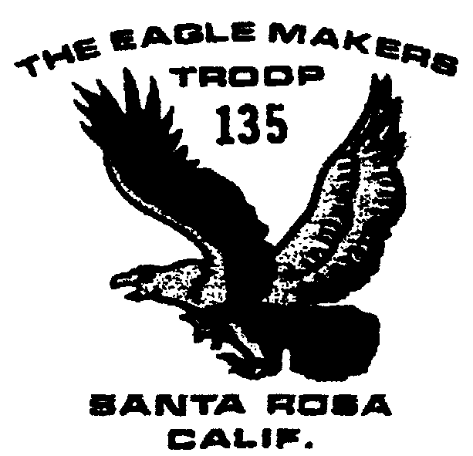

September 2003
Outings and Events

9/8 Meeting time returns to 7:30-9

9/20-21 Coast Camping

9/22 Court of Honor

9/23 Committee Meeting

10/18-19 Camping

10/21 Committee Meeting

11/15-16 Pt. Reyes Campout

September campout
Details for the September camping weekend have not been worked out yet, but should be forthcoming soon. It will be held the third weekend of the month as usual

Meeting Time Change
With school back in session, the regular troop meetings will return to a 7:30 start time on September 8. Scouts should wear their full uniforms.

Sign-up sheets
Lee Gunn has designed some standard sign-ups sheets to be used for Scout outings. The sheet includes the Scout’s phone number, whether or not he’s coming and/or paid and how many seat belts are available in his parents’ car if they drive! Hopefully this will keep us better organized!

Court of Honor
The second Court of Honor of the year, to award merit badges earned over the summer, will be held on Monday September 22 at the normal meeting. Families are invited to attend to applaud the hard work the scouts have put in this summer.

T-shirts
Brett has ordered another batch of tan “class B” Troop 135 t-shirts for those boys who either never got one or possibly need a new one. For new boys to the troop, the cost is $5. For boys wanting to replace a t-shirt, the cost is $18.

August activities
The reports from Yosemite are of a good trip. Thanks to adult hikers Brett Lake, Bill Cummings, Rick Ryall, Amy Villegas, DavidTorre, Rick Ziesche, and Valley Floor adults Lou Azevedo and Julio Soto.
The Mt. Wittenberg hike with Webeloes from Pack 127 also went well. Five Webeloes and four Scouts from our troop earned a Rim of the Bay patch and everyone had a great time.

Fall Activities
Registration for next year will be coming up soon with the individual scout fees due at the Council Office in December. Last year’s fees were $70; this year’s fees have yet to be determined, but should be similar.
The Saturday morning before Christmas, Troop 135 traditionally assists Church of the Roses distribute food baskets.
Our big fund raiser for the year is recycling Christmas trees, scheduled for the Saturday mornings following Christmas and New Year’s Day. All three December events usually finish up before noon.
Christmas tree recycling is an opportunity for scouts to add funds to their Scout accounts. Additionally, aluminum can recycling with Phil Weil continues each week—another way to offset some of the costs of Scouting.

Training opportunities
Various BSA training classes, including Youth Protection and Boy Scouts Specific Training, will take place on October 18. Check the web for more information: http://www.recbsa.org/pomo/#yp. Some training is every third Thursday at the Council Office, as well.

