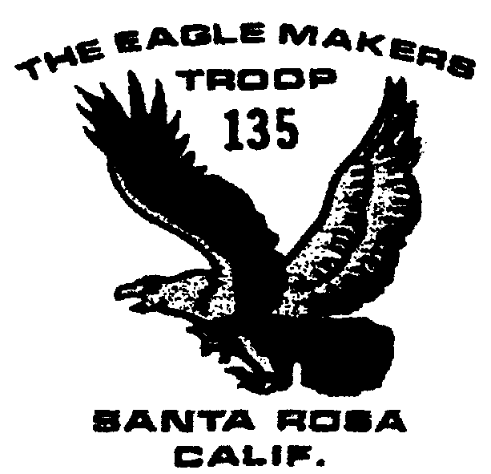

Troop 135 Newsletter
October 2003

Outings and Events

10/21 Committee Mtg. 7:30

10/24-26 Desolation Wilderness Camping

11/1 Registration fees due

11/15-16 Pt. Reyes Camping

11/18 Committee Mtg. 7:30

12/27 & 1/3 Tree Recycling

1/16-18 Ski Trip

7/18-25/2004 Scout Camp

Registration Fees
Troop 135 registration fees are due by November 1. The fee for each boy will be $70. This will cover recharter, Boy’s Life and is in lieu of any sort of weekly or monthly dues. The fee covers camping sites over the year, merit badges, supplies, equipments and awards.
Adult fees are $15 for the year and any adults going on scout functions need to be registered with the troop.

October Camping Trip
The troop is planning a camping outing to the Desolation Wilderness on October 24-26, the fourth weekend of the month. Because it’s a four hour drive away, the boys will leave the church parking lot on Friday but are encouraged to bring their schoolwork, as the return will be late on Sunday. Campers also should bring thermal underwear!

Donations
Donations of good, usable camping equipment are always welcome to the troop. The dream list includes another REI two man Dome 2 tent! The troop uses Coleman Peak 1 stoves and could use some more Coleman screw-in type fuel bottles. Treasurer Marie Borrel can provide a receipt for tax purposes.
In addition, if your son outgrows any scouting uniform which is still in a good enough condition for someone else to use, let us know. Pants are always in short supply!

Looking ahead
There won’t be a camping trip in busy December!
The boys traditionally do a good turn in December when they assist Church of the Roses in handing out food baskets for Christmas. The date usually is the Saturday before Christmas.
Tree recycling, our biggest fund raiser, is on for the two Saturday mornings after Christmas, generally from 9 until noon.
Skiing in Lake Tahoe has been planned for the Martin Luther King weekend. The boys go up Friday night and stay at the Truckee Youth Center, ski on Saturday and return on Sunday. The cost frequently is high owing to the expense of renting ski equipment and lift tickets. More later.

Training opportunities
Various BSA training classes, including Youth Protection and Boy Scouts Specific Training, will take place on October 18 starting at 8 am. Check the web for more information: http://www.recbsa.org/pomo/#yp. Some training is every third Thursday at the Council Office, as well.

T-shirts
Troop 135 tan “class B t-shirts are available. For new boys to the troop, the cost is $5. For boys wanting to replace a t-shirt, the full cost is $18.

