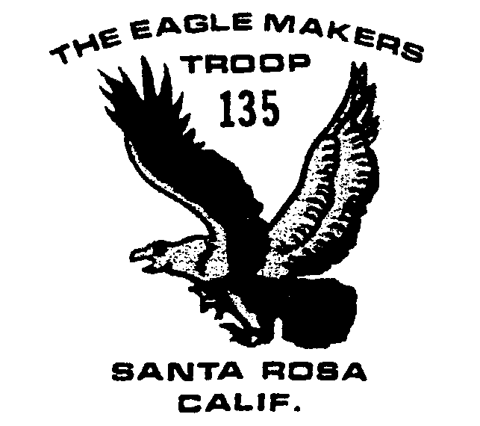
May 2004

Outings and Events

Today—deposit needed for Scout camp, ASAP

5/10 Meeting at Howarth Park’s Lake Raphine. Early pick up—8:30

5/15-16 Canoe Trip—Lake Sonoma

5/18 Committee Mtg. 7:30

6/14 Court of Honor/ Summer meeting hours begin 7-9.

6/18-20 Carr Lakes Camping

7/18-25 Boy Scout Camp

8/6-14 Long Yosemite backpack

8/9-13 Short Yosemite backpack

8/14-17 Yosemite Volunteer Project

9/17-19 Trinity Peaks Backpack trip

Summer Camp
Deposits for summer camp are needed as soon as possible, $100 will be fine.
The scouts will be attending Marin Sierra Summer Camp July 18-25. The cost this year is $205 if paid to the Marin Council by June 1 (get the money to Lou May 24). After June 1, the fees go up to $230. The fee for each leader is $45.
In addition to everything else, Marin Sierra Summer camp has its own form you also need to fill out.

Health Forms
Health forms are good, basically, for two rounds of summer camp. Please check to see if your son’s form is still up to date.
Bill Cumming has revised the introduction handout to Troop 135 and updated the medical forms. If anyone would like a copy, they can email him at wcumming@wcumming.com.

Preparing for canoeing
The troop will meet at Howarth Park’s Lake Raphine on Monday night, May 10 at the usual 7:30, to practice for the canoeing trip the following weekend. Parents are asked to be at the park’s parking lot by 8:30 that night, in case we need to leave earlier than our usual time, owing to the park closing.

Canoeing Trip
The boys will take a canoeing trip May 15-16 at Lake Sonoma.

Adult Training
Adults need to be trained on a routine basis in CPR (especially for outing involving water) and BSA Youth Protection. We are trying to arrange a specific meeting night to have the Council come out and provide us with CPR training.
Youth Protection training can be done through the Council office on every third Thursday during the school year. Or, you can do the training on-line in the convenience of your own home at:

http://www.scouting.org/pubs/ypt/ypt.jsp
Because bugs are still being worked out, Bill advises you to print out the last page and be prepared to fax it to the council for credit. It takes about 45 minutes to do it all on-line.

Big Basin Camping
The troop had a successful outing to the Big Basin Camp. They saw lots of waterfalls, “walking down them when they were wet was scary,” according to one unnamed scout.
It was a beautiful weekend, great scenery and the boys did well. They were instructed to hang their packs at night, but they didn’t hang the food properly and the raccoons got into the food. They managed to survived, however!

Yosemite Trip
There will be two trips through the Yosemite back country this summer, a “long” trip from as early as possible on Friday, August 6 through August 14, where they will rendezvous with the “shorter” trip in the Valley. The shorter trip will run August 9-14. All boys will participate in a service project at the Indian Museum in the Valley August 14-17. Some non-hiking parents will help chaperone the boys during the project while some hiking parents head for home (and work).

