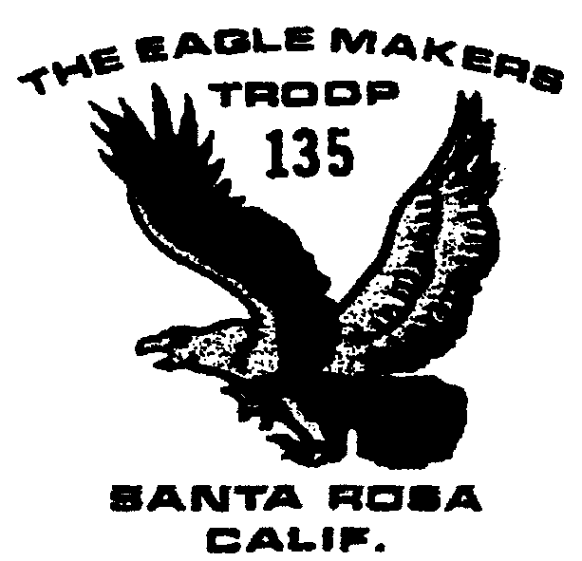

Troop 135 Newsletter
June 2003

June 2003 Newsletter
Outings and Events

6/2 Wente money due

6/7 Day Hike

6/9 Court of Honor

6/16 Meeting time changes to 7-9

6/20-22 Canoe Trip

7/12-13 Sailing Trip

7/20-26 Wente Camp

8/7-17 Yosemite 25 miler

8/9-17 Yosemite 13 miler

8/14-1 7 Yosemite project

8/23 Mt. Wittenberg Hike

9/20-21 Coast Camping
Scout Camp Money
The cost for Wente Scout camp is $225. Final payment is due to the troop on June 2. Checks made out to Boy Scout Troop 135 should be given to Lou Azevedo, who will be going to camp with the boys. If there are difficulties, please let Lou know. The boys can use money from their scout account towards camp fees.

June 7 Hike
This is a “shake down” hike at Sugarloaf State Park’s southeast rim for boys going on the Yosemite trip. The troop will meet at church at 8 am and will return by early afternoon. They will hike with full packs under Phil Weil’s supervision.

Court of Honor
The semi-annual Court of Honor is where the boys are recognized for rank advancement and earned merit badges. Families are encouraged to attend.
On June 16, troop meeting times will change to summer hours: 7 to 9 pm.

Canoe Trip
Departure for the June 20-22 canoe trip on the Navarro River will be from the church at 5:30 Friday night. First night’s camp with be at Paul Dimmick State Park, with the second night along the ocean. If you have access to a canoe, please contact Scoutmaster Brett Lake.

Yosemite
Yosemite trip plans are set except we still could use someone to occupy a Bridalveil campsite from Aug 7 to Aug 10. They could stay longer if they like. The troop will cover the campsite cost.
There are two groups of backpacking scouts:
1. The 25 mile Bushwack Backpack leaves Santa Rosa August 7, backpacks until August 13 and joins the Yosemite volunteers on August 14.
2. The 13 mile Ostrander Backpack leaves Santa Rosa August 9 for Bridalveil, takes a day hike, does a two night backpack, and joins up with the Bushwack Backpack group.
Both groups have a Yosemite Valley Day on August 14, and will work on the Yosemite Indian Museum volunteer project August 15-16 before returning to Santa Rosa August 17.
The anticipated cost for each participant will be about $100. $50 should cover permits, rentals, and valley food, with another $50 allotted for trail food. Final total will be in August.

Aluminum Cans
Boys can turn in aluminum cans for recycling on Monday nights with Phil Weil. Monies earned will be deposited in their troop account.

Newsletter
Want to get this newsletter via e-mail? Contact Michelle Ule at Robertule@aol.com

