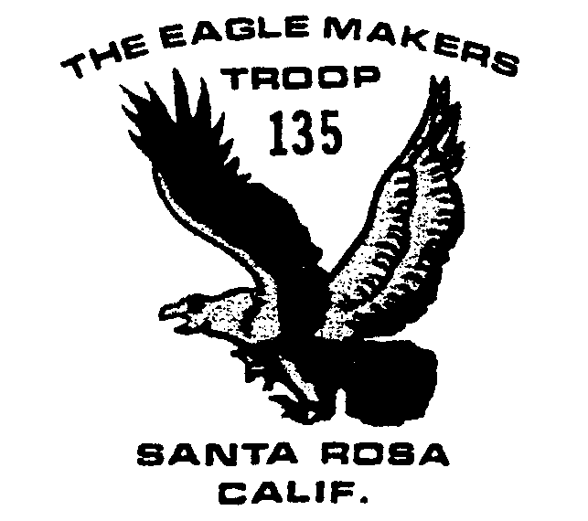
March 2004

Outings and Events

3/15 Scout Swim YMCA 7:15

3/16 Committee Mtg. 7:30

3/19-21 Camping Henry Coe SP

4/16-18 Big Basin Camping

4/20 Committee Mtg. 7:30

5/1-2 Camporee

5/15-16 Canoe Trip

5/18 Committee Mtg. 7:30

6/14 Court of Honor/ Summer meeting hours begin 7-9.

6/18-20 Carr Lakes Camping

7/18-25 Boy Scout Camp

8/7-15 Yosemite backpack

Thanks
Thanks to all the boys and adults who helped on Scout Sunday. Donations, after expenses, amounted to $100 and were split between the scout accounts of all the boys who worked.

Scout Swim
The Troop will meet at the YMCA on College Ave. on March 15 at 7:15 for an hour of swimming and testing for various requirements.
March Camping
The Scouts will be camping at Henry Coe State Park near Gilroy leaving Friday March 19 in the late afternoon and having a flashlight hike that night, about a mile in to the camp site, before taking a 3-6 mile hike on Saturday.

Big Basin Camping
The second weekend of spring break, April 16-18 the boys will be hiking near Santa Cruz. Some drivers are still needed to help with the ferrying, see Bill Cummings if you’re interested. This is a popular hike, 18 camping slots have been reserved.

Welcome New Scout
Welcome to new scout Loren Kezer!

Summer Camp
The scouts will be attending Marin Sierra Summer Camp July 18-25. The cost this year is $205 if paid to the Marin Council by June 1 (get the money to Lou May 24). After June 1, the fees go up to $230. The fee for each leader is $45.

Health Forms
Health forms are good, basically, for two rounds of summer camp. Please check to see if your son’s form is still up to date. Class one and two forms can be accessed over the Internet: http://www.scouting.org/forms/34414.pdf.
Class three forms are recommended for all boys participating in our Troop’s activities: http://www.scouting.org/forms/33412.pdf. Lou has forms also.

Adult news
** Youth Protection Training is held at Council every third Thursday 7-9 pm. Previously trained? Up-date your training on-line (needed every three years): http://www.indianhead.org/training/youthpro/ypt-online.htm, just make sure you sign-up for the official training!
**The troop needs an adult willing to attend the Council Roundtable the second Tuesday of the month for two hours. Roundtable is where all the Scout troops gather to share and disseminate information.
**We still are looking for more merit badge counselors, particularly to round out the Eagle requirement badges and back up our long time counselors. If you have an interest or ability to help with the following, please let us know: Emergency Preparedness, Salesmanship, First Aid and Environmental Science.

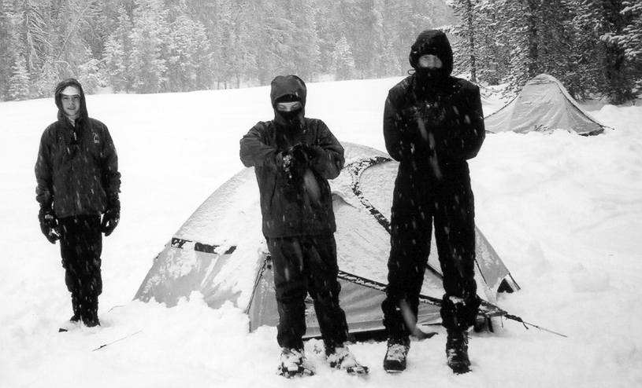

Cyrus, Michael and James 2/14

