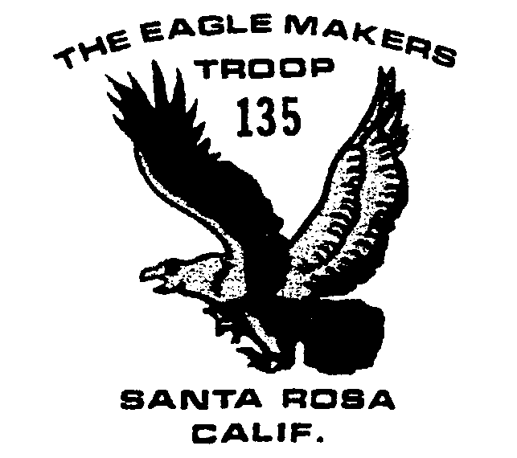

July 2003

Outings and Events

6/30 CPR Adult training

7/11-13 Sailing Campout

7/15 Committee Meeting

7/20-26 Wente Camp

8/7-17 Yosemite 25 miler

8/9-17 Yosemite 13 miler

8/14-17 Yosemite project

8/23 Mt. Wittenberg Hike

9/20-21 Coast Camping
CPR Training
The troop is required to have at least one adult trained in CPR on each outing. To this end, the annual troop adult CPR training course will be held THIS Monday, June 30, during the regular 7-9 pm Scout meeting at the church.
While the training itself is free, there is a $10 charge for the qualifying Red Cross card proving you have passed the test at the end of the training session.

Sailing Trip
The troop will be taking a sailing/hiking camping trip up to Lake Sonoma July 11-13. Meeting at the church at 5:30 on Friday night, the boys will travel up to the lake and hike 3 miles from Old Skaggs Spring Road to the Buck Pasture “sail in” camp ground on the west arm of the lake.
CDR Robert Ule, USN, is in charge of the trip and will sail his catamaran to the camping site. At least one other sail boat should be available. Please let Mr. Ule know if you can or would like to bring up another boat, particularly a second canoe to work on the Canoe Merit Badge.
Only 24 people, total, can come. MREs will be served for one meal.

Wente Scout Camp
Scouts attending Wente Scout camp will meet in the Albertson’s parking lot at 10 am on Sunday July 20 to drive up to the camp located north of Willits. The boys should bring a sack lunch.
They will return to the church the following Saturday, July 26, about noon. Parents wanting to pick up their sons at camp should do so by 9 am on July 26.
Lou Azevedo is in charge and will be at camp all week, along with Dave Mitchell. Contact Lou for additional information, especially if you are interested in coming up to help a day or two at camp!

Yosemite Plans
Two Yosemite backpacks from Bridalveil Trailhead are planned, one August 7-17 and the other August 9-17. The Bushwack Backpack group leaves Santa Rosa August 7 for their 25 mile hike.
The Ostrander group leaves August 9 and will day hike before doing a 2 night backpack, meeting the first group at Ostrander Lake 6 miles from the trailhead. All the backpackers will walk out together on August 13, have a day in Yosemite Valley on August 14, and then do two days of volunteer work at the Indian Museum in Yosemite Village. Everyone will be home on Aug 17.
We would prefer one more adult to accompany each of the backpack groups so please let Brett know if you can help. Some adults and registered scouts may attend just the Indian Museum project from August 14 to 17.
Troop 135 has done a service project at the Indian Museum for a number of years.

Aluminum Cans
Boys can turn in aluminum cans for recycling on Monday nights with Phil Weil. Monies earned will be deposited in their troop account.

Newsletter
Want to get this newsletter via e-mail? Contact Michelle Ule at Robertule@aol.com

