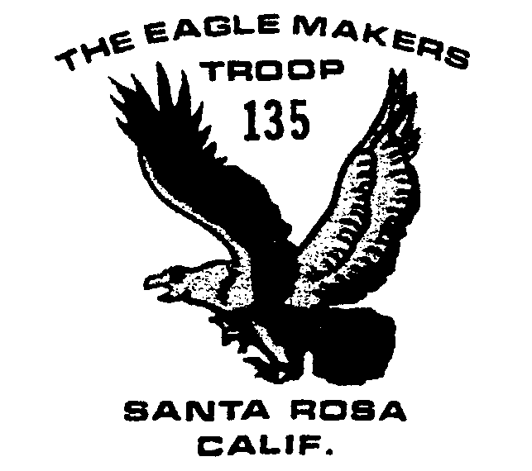
February 2004

Outings and Events

2/1 Scout Sunday NEW DATE

2/3 Snow camp pack inspection

2/14-16 Snow Camp

2/17 Committee Mt. 7:30

3/16 Committee Mt. 7:30

3/20-21 Camping

4/16-18 Big Basin Camping

5/1-2 Camporee

5/15-16 Canoe Trip

6/18-20 Carr Lakes Camping

7/18-25 Boy Scout Camp

August Yosemite backpack

9/17-19 Canyon Trails

Scout Sunday
Owing to the needs of Church of the Roses, Scout Sunday has been moved UP to THIS Sunday, February 1. Some boys will be needed at church by 8 o’clock, with the bulk of them needing to be there by 9:30.
This is our annual breakfast to thank the church for chartering our troop. Scouts will usher the 10 o’clock service, provide a continental breakfast about 9:30 (following the first service) and cook a full pancake breakfast after the 10 o’clock service. Adults are always helpful in the kitchen and to oversee the boys acting as waiters.

Snow Camp
The troop will be camping in the snow February 14-16. They will leave from church at 6 am, Saturday, February 14 heading to Yosemite’s Badger Pass or Upper Pines, depending on the weather. They expect to return Monday night, February 16 about 8.
The boys will need cold-wet-snow gear as required in the troop gear checklist. Final count of attending boys is due Monday, February 3 and there will be a full pack inspection for those going. The weather is expected to be snow flurries at 30-40 degrees, falling to 20 at night. Toe warmers are recommended but not necessary! The boys need to cover their packs, a large plastic garbage bag works fine.
Snowshoe rental is $32 a pair, with poles scarce. Money is due by February 10. Mr. Cumming will pick up the snowshoes. If the boys have crossing country or touring skis, they can bring them.

Adult news
** We are working on arrangements for the annual Youth Protection Training. For those already trained, you can up-date your training on-line (necessary every three years) at http://www.indianhead.org/training/youthpro/ypt-online.htm, just make sure you sign-up for the official training!
**The troop needs an adult willing to attend the Council Roundtable the second Tuesday of the month for two hours. Roundtable is where all the Scout troops gather to share and disseminate information.
**Check your son’s medical records to make sure he doesn’t need a new form for Summer camp!
**Taxes—the IRS allows volunteer drivers who itemize to deduct car expenses up to 14 cents a mile when driving for charitable organizations like the boy scouts. You need to keep a running log throughout the year, noting the odometer readings. Check with the IRS for further information!
**We need ideas for fund raising opportunities for the boys, if you’ve got any, please pass them along!
**We still are looking for more merit badge counselors, particularly to round out the Eagle requirement badges and back up our long time counselors. If you have an interest or ability to help with the following, please let us know: Emergency Preparedness, Salesmanship, First Aid and Environmental Science.

