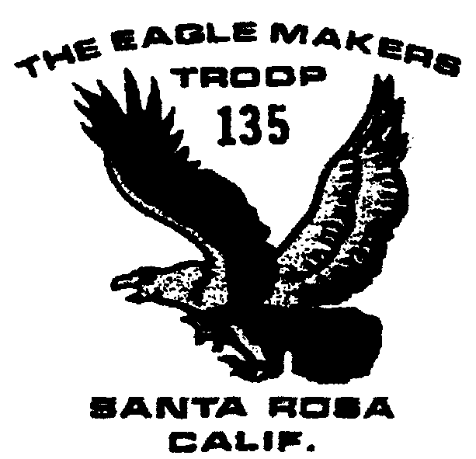

\\

Troop 135 Newsletter
August 2003
Outings and Events

7/28 Pack inspection

8/7-8/17 Long Yosemite

8/9-17 Shorter Yosemite

8/11 NO MEETING

8/14-17 Yosemite Valley Project

8/19 NO Committee Meeting

8/23 Mt. Wittenberg Hike

9/5-7 and 9/20-21 Wood Badge training

9/8 Meeting time changes
back to 7:30-9

9/20-21 Coast Camping

9/23 Committee Meeting

10/18-19 Sugarloaf Camping

Pack Inspection
All boys going on either Yosemite hike need to bring their backpacks, fully equipped for the trip except for food, with them to the Scout meeting on July 28. The troop will conduct an inspection of just exactly what each boy really needs to carry in his pack! Boys not going on the hike do not need to bring their packs.

Yosemite plans
Attached to the newsletter will be a fact sheet for all involved in the Yosemite trip, detailing phone numbers, plans, dates and other information.
Please note the proposed itinerary includes a short acclimatization period for the boys to get used to the high altitudes in which they will be hiking.
Costs for the trip are $70 for permits, camping, etc. Food, two meals on the road and any souvenirs will be extra. Bill Cummings suggests budgeting about $120 for the short trip and $140 for the longer trip. Tom Hauck is working with the boys planning the menus.
Food will be packed into the bear cans needed for Yosemite at the August 4 troop meeting.

Meeting Time news
There will be no meeting on August 11 when most of the troop is in Yosemite. The August Committee meeting also has been canceled. Meeting times return to 7:30-9 on Monday, September 8.

T-shirts
Brett has ordered another batch of tan “class B” Troop 135 t-shirts for those boys who either never got one or possibly need a new one. For new boys to the troop, the cost is $5. For boys wanting to replace a t-shirt, the full cost is $18. We hope to have the shirts in hand before the boys leave for Yosemite.

Wood Badge training
The council will hold Wood Badge training for adults interested in more advanced camping skills on September 5-7 and September 20-21. For further information, check out the web site: http://www.recbsa.org/pomo/#WoodBadge

Mt. Wittenberg Hike
The weekend after Yosemite, boys from our troop have been asked to take a hike up Mt.Wittenberg with the cub scouts from Troop 127. Further details will be announced at the Troop meeting August 18.

