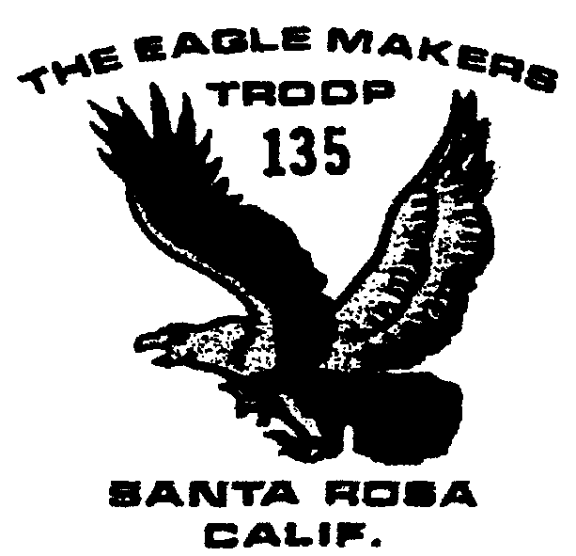

November 2003

Outings and Events

11/1 Registration fees due

11/15-16 Pt. Reyes Trip 8 am

11/18 Committee Mtg. 7:30

12/13 Food baskets (includes breakfast at church) 9am

12/16 Committee Mtg. 7:30

12/27 & 1/3 Tree Recycling

1/16-18 Ski Trip

2/14-15 Snow Camping

7/18-25/2004 Scout Camp

Registration Fees
Troop 135 registration fees are due by November 1. The fee for each boy will be $70. This will cover rechartering, Boy’s Life and is in lieu of any sort of weekly or monthly dues. The fee covers camping sites over the year, merit badges, supplies, equipments and awards.
Adult fees are $15 for the year and any adults going on scout functions need to be registered with the troop. Merit badge counselors need to be registered as well.
Pt. Reyes
The November trip is to Pt. Reyes which is frequently difficult to visit in the summer. The troop will leave Saturday at 8 am from church, back early Sunday afternoon.

Food Baskets
The troop will assist Church of the Roses distribute food baskets to needy families Saturday, December 13, beginning at 9 am with a free breakfast at church. Parents interested in driving are welcome as well. The boys usually distribute flyers about tree recycling after they finish handing out food baskets.

Tree Recycling
Tree recycling is the biggest fund raiser of the year for the troop. Profits are split between the troop and boys who assist in the recycling efforts. Parents with trucks are needed, strong boys as well. More details next month.

Ski Trip
Always the most expensive weekend outing of the year, the annual ski trip will take place Martin Luther King weekend, under the direction of Bernard Passamar. The boys stay at the Truckee Youth Center and will ski at Sugarbowl. Skiing or snowboarding is done on Saturday, with the boys returning on Sunday. In order to get a reduced admission lift ticket, boys need to decide early which snow activity they will do. All boys who do not have the skiing merit badge are required to take a morning lesson.

Merit Badges
Attached to the newsletter is a list of the 120 possible BSA merit badges, along with a Merit Badge Counselor application. The heart of advancement for the boys is the ability to work on merit badges. If you have a talent, job, interest or skill in one of the possible merit badges, please consider becoming a counselor. A 14 page list describing the difficulty, number of requirements and duration of individual merit badges will be posted on the Scout bulletin board at Church of the Roses. In addition, Bill Cumming has a book describing requirements, or they can be examined at: http://usscouts.org/advance/docs/MrDsReview.html

Miscellaneous

James Ryall is the new Senior Patrol Leader.
Can recycling for individual accounts continues. Marie Borell can tell the boys how much they have in their accounts
