Luther Burbank’s lack of ability to develop good, profitable relationships with various promoters after about 1905 is a part of his story.

The Luther Burbank Society and its Luther Burbank Press published the 12-volume set called, Luther Burbank, His Methods and Discoveries and Their Practical Application. These included 1,260 photos which help us significantly in understanding Burbank’s work and environment. Issued in 1914-1915, the text has been noted for its errors.

In 1921, P. F. Collier and Son Company published How Plants are Trained to Work for Man. At least, in print, the books were “by Luther Burbank, Sc. D.” The “Sc. D.” apparently refers to Burbank’s receipt of the honorary doctorate from Tufts University. “These eight volumes are not a compilation from the works or words of others…” according to the “Word to the Reader” in Volume I.

Yet, the copyright notices for the 1921 books list the 1914-1915 books.

We know that nearly all of the 392 photos in the 1921 books come from the 1914-1915 books.

If the new books are a truly new work, we would expect each volume to pull photos from across those available in the twelve 1914-1915 volumes.

If the new books are mostly a rework of the 1914-1915 volumes, we’d expect the photos to be used in about the same general groupings as the original work.

In plotting the numbers of photos from each volume going into each volume, if there was an even distribution of photo use, we’d expect a chart such as
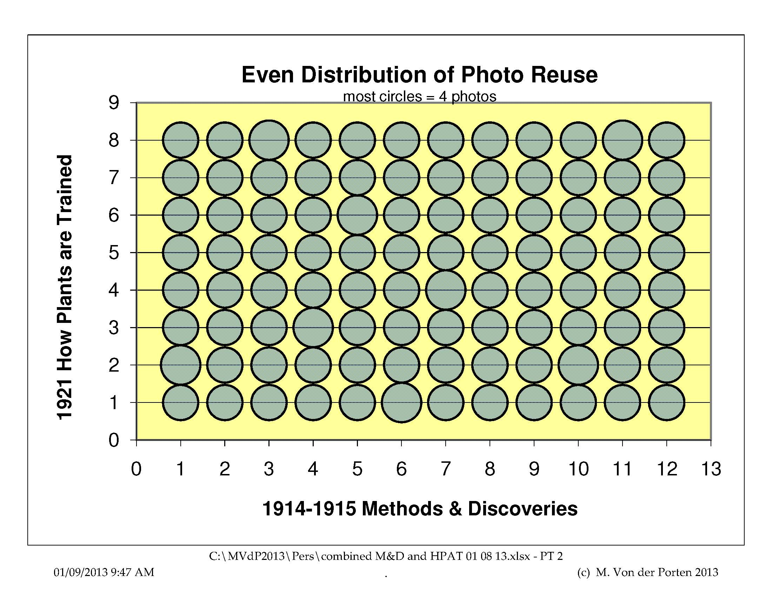

This indicates that about four photos from each of the original twelve volumes would be found in each of the new eight volumes.

If the distribution was random, we might expect a distribution which looks like this:

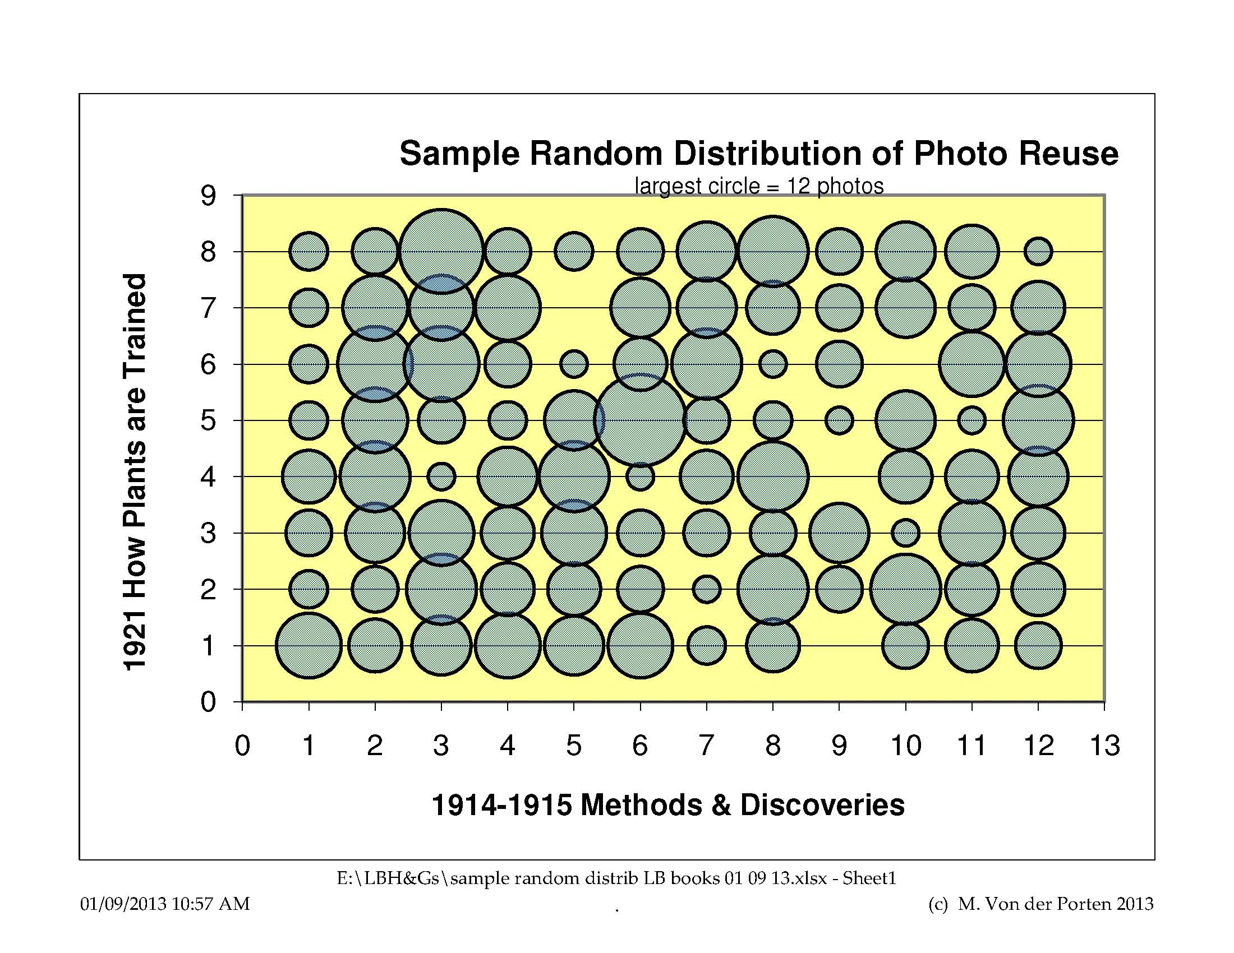

In matching the photos between the sets of books and plotting how many photos came from each of the old books and in which of the new books they appear, we can plot the results.

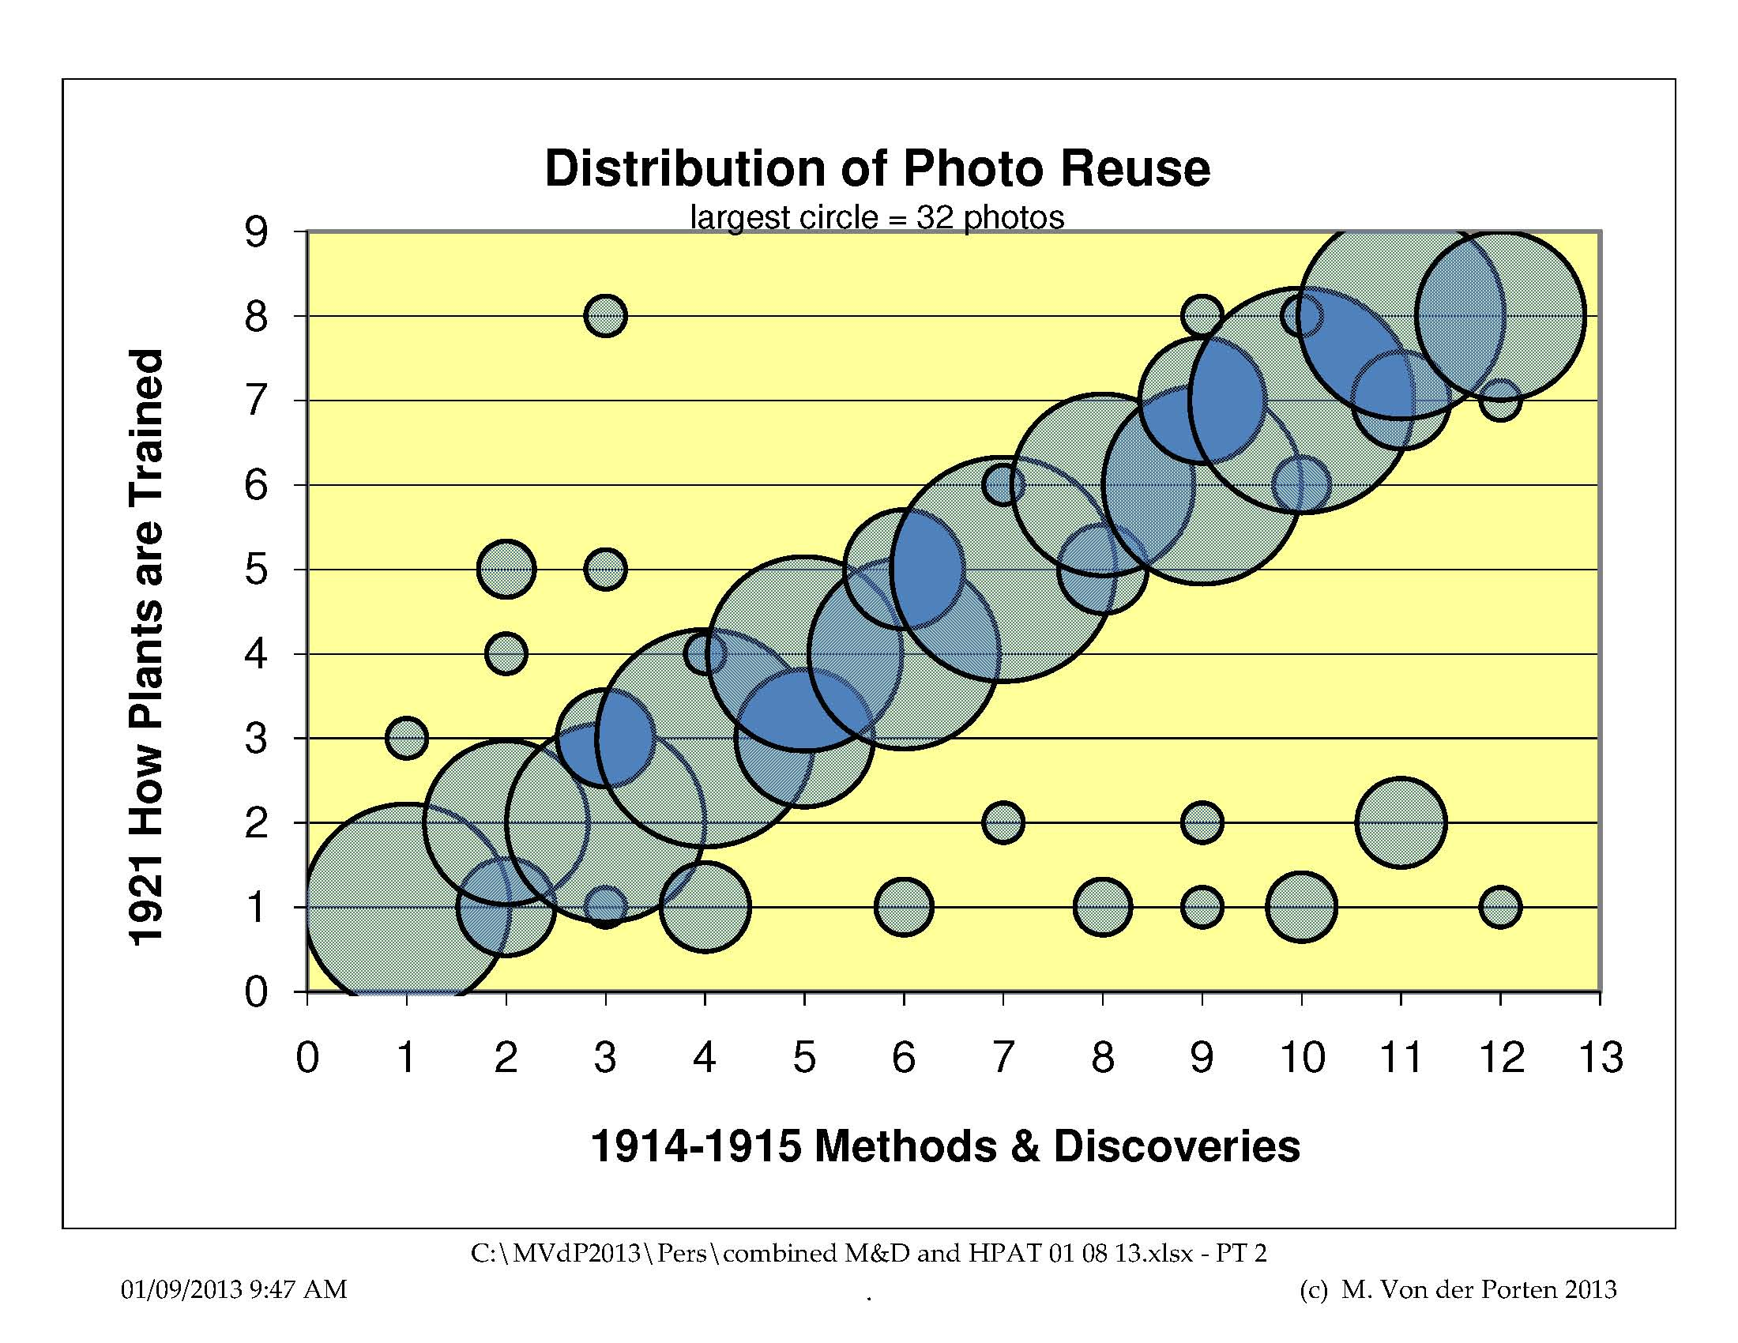

As the chart shows, there is a very strong correlation between the original 1914-1915 books and the 1921 books. An r² of 73% has been calculated, indicating that the correlation is quite strong.

Not only is there a strong correlation that “the photos from one volume are used primarily in one new volume,” there’s a strong correlation that “the photos in the first 1914-1915 volume are used in the new first volume, the photos in the last 1914-1915 volume are used in the last new volume, and the same in between.”

As with much Burbank promotional material, we can now infer that the claim that “these eight volumes are not a compilation from the works or words of others” is largely an exaggeration.

This can be added to the list of disappointments in Burbank’s ancillary efforts.

Michael Von der Porten
January 9, 2013
mikevdpca@aim.com

Rebecca Baker has documented Burbank’s successes in finding partners for distributing his developments, especially plums and prunes, until about 1905.

